Retrievers in LangChain
https://www.youtube.com/watch?v=pJdMxwXBsk0&list=PLKnIA16_RmvaTbihpo4MtzVm4XOQa0ER0&index=15
https://colab.research.google.com/drive/1vuuIYmJeiRgFHsH-ibH_NUFjtdc5D9P6?usp=sharing
00:00 – Intro
00:50 - Recap
02:01 - What are Retrievers
05:29 - Type of Retrievers
09:55 - Wikipedia Retriever & Code Demo
15:50 - Vector Store Retriever
22:09 - Maximum Marginal Relevance - MMR
30:33 - Multi Query Retriever
39:49 - Contextual Compression Retriever
47:54 - More Retrievers
LangChain Retrievers — Video Notes
1. Introduction
Topic: Retrievers in LangChain — a crucial component for RAG (Retrieval-Augmented Generation) applications.
- Importance:
  - Essential for fetching relevant documents based on user queries.
  - Key for building advanced RAG systems with multiple types of retrievers.
- Video goal: Explain retrievers, their need, types, and demonstrate coding examples.

2. Recap
- Previous videos covered:
  - Document Loader — loading data into LangChain.
  - Text Splitter — splitting documents into manageable chunks.
  - Vector Stores — storing document embeddings for semantic search.
- Today’s focus: 4th core component — Retrievers.
- Once all four components are understood, you can start building RAG applications.

3. What Are Retrievers?
- Definition:
A retriever is a component in LangChain that fetches relevant documents from a data source in response to a user query.
- How it works (conceptually):
  - You have a data source (could be vector store, API, database, etc.).
  - User sends a query.
  - Retriever scans the data source, identifies relevant documents, and fetches them.
  - Output: Multiple Document objects in LangChain format.
- Analogy: Acts like a search engine for your data source.
- Key points:
  - LangChain has multiple retrievers, not just one.
  - Retrievers are runnables, meaning they can be invoked like a function.
  - Retrievers can be plugged into chains to enhance system flexibility.
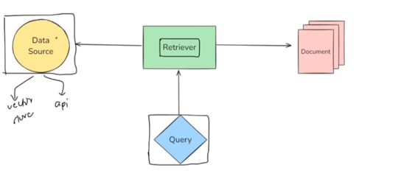

4. Types of Retrievers
- Two main ways to categorize retrievers:
  - Based on Data Source:
    - Wikipedia Retriever → queries Wikipedia API.
    - Vector Store Retriever → fetches from vector databases (Chroma, Weaviate, etc.).
    - Archive Retriever → fetches research papers from online archives.
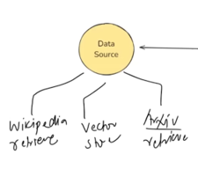
  - Based on Search Strategy:
    - Maximum Marginal Relevance (MMR) Retriever.
    - Multi-Query Retriever.
    - Contextual Compression Retriever.
- Summary: Retrievers differ either by the data they query or by the strategy they use to search.
- Note: LangChain has 20–30+ retrievers; this video covers the most common and useful ones.

5. Wikipedia Retriever & Demo
- Wikipedia Retriever:
  - Queries Wikipedia API to fetch relevant articles.
  - Internally uses keyword matching — no semantic or syntactic search.
  - Returns results as LangChain Document objects (with metadata and page content).
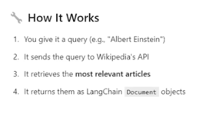
- Demo Highlights:
  - Import the Wikipedia retriever class.
  - Create a retriever object:
    - Specify number of documents to fetch.
    - Specify language (default is English).
  - Formulate a query (e.g., “Geopolitical history of India and Pakistan from the perspective of a Chinese”).
  - Invoke retriever → returns most relevant articles.
- Clarification: Not a document loader — it performs searching and ranking, making it a true retriever.
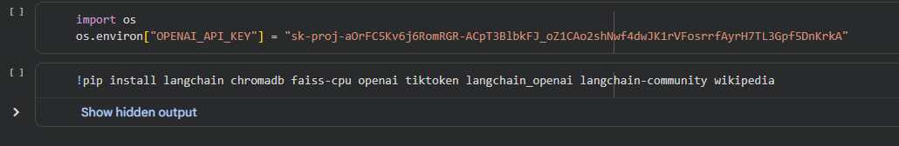
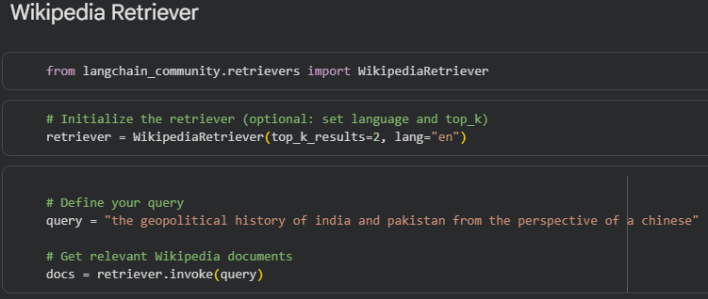
The retrieved document object contains both metadata and page content. We will iterate over the documents and retrieve only the page content.
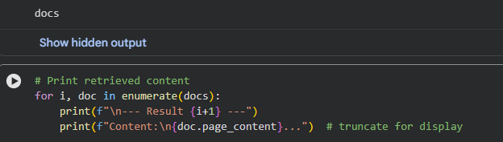

6. Vector Store Retriever
- Definition: Retrieves documents from a vector store using semantic similarity.
- How it works:
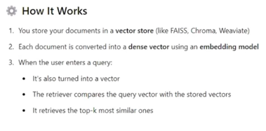
  - Documents are stored in a vector store (e.g., Chroma, Weaviate).
  - Each document is converted into a dense vector using an embedding model.
  - User query is also converted to a vector.
  - Perform semantic search → fetch top-K similar documents.
- Demo Highlights:
  - Use Chroma as vector store and OpenAI embeddings.
  - Create retriever from vector store: vectorstore.as_retriever().
  - Invoke retriever with query → get Document objects.
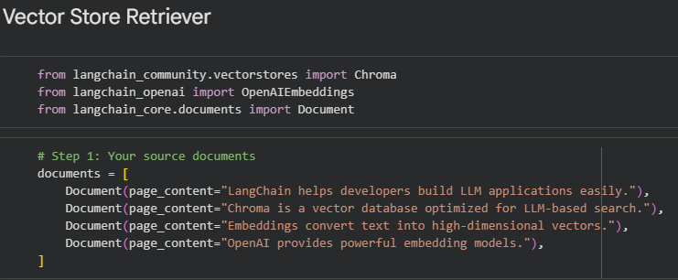
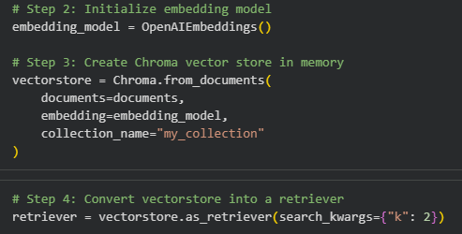
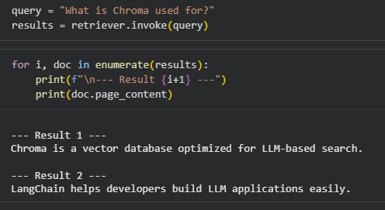
- Why use retriever instead of direct vector store search?
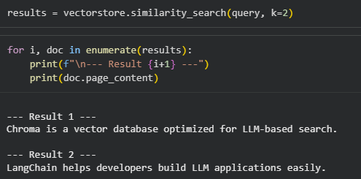
Vector stores support only one search strategy.
Retrievers allow flexible and advanced search strategies to be plugged in.

Types of Retrieval based on Retrieval mechanism
Maximum Marginal Relevance (MMR)
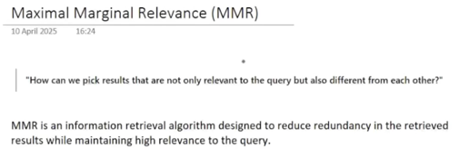
MMR is a retriever that can be differentiated based on the retrieval mechanism or strategy. Its full form is Maximum Marginal Relevance.
MMR is designed to solve a common problem in many retrievers: redundant results.
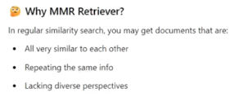

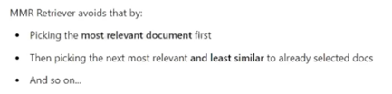
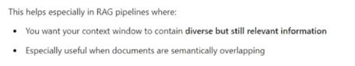
For example, consider a document source with five documents about climate change. If you pause a video and read these documents, you might notice that:
- Document 1 discusses glaciers melting rapidly in the Arctic region.
- Document 2 discusses the same topic with slightly different wording.
- Document 3 discusses deforestation.
- Document 4 discusses wildfires.
- Document 5 covers other impacts like coastal flooding.
If a user searches with the query, "What are the adverse effects of climate change?", a normal retriever using similarity search might return the top three documents with the highest relevance.
The issue here is that the first two results may convey the same information about glacier melting, while the third introduces a different perspective (deforestation). Ideally, we want results that are both relevant and diverse, showing multiple perspectives rather than repeated information.
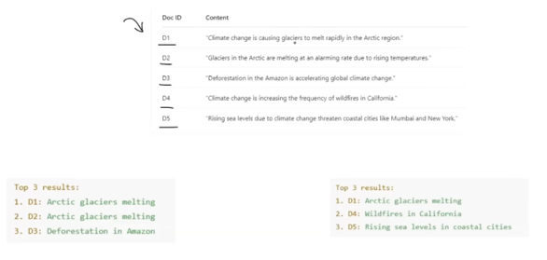
MMR Philosophy:
MMR aims to pick results that are not only relevant to the query but also different from each other.
How MMR works:
- Select the most relevant document first.
- Next, select a document that is relevant but maximally dissimilar to the previously selected documents.
- Repeat the process until the desired number of documents is fetched.
Definition:
MMR is an information retrieval algorithm designed to reduce redundancy in retrieved results while maintaining high relevance to the query. Unlike normal similarity searches that may return repetitive documents, MMR ensures multiple perspectives are presented.
Implementation in Code (LangChain Example):
- Create sample documents.
- Set up a vector store (e.g., using Chroma or FAISS/Faiss Facebook AI Retrieval System).
- Convert documents into embeddings and populate the vector store.
- Create a retriever object and specify the search type as MMR instead of normal similarity search.
- Set the lambda parameter (0–1) to control diversity:
  - 1 → behaves like normal similarity search.
  - 0 → maximizes diversity.
  - Values between 0 and 1 → balance relevance and diversity.
- Fetch results using the retriever.
Observation:
- With lambda = 1, MMR behaves like similarity search, potentially returning redundant documents.
- Reducing lambda increases diversity, showing more distinct perspectives while remaining relevant.
- This approach ensures users receive relevant yet diverse results, avoiding repeated content.
MMR is particularly useful when the goal is to present different perspectives to a user without compromising relevance.
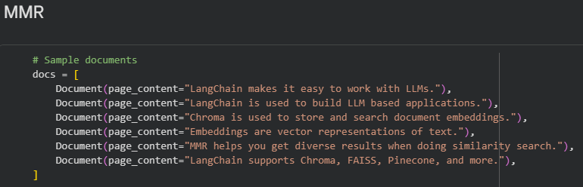
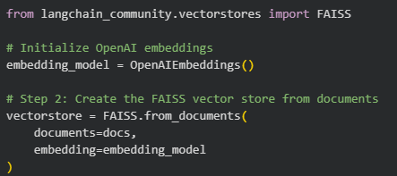
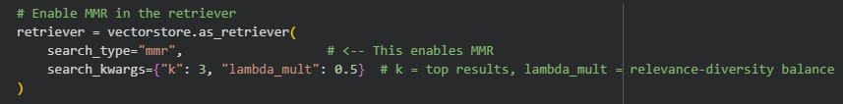
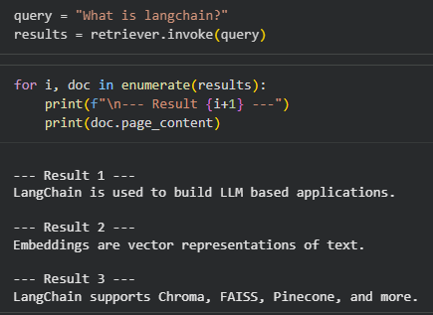

Multi-Query Retriever
The Multi-Query Retriever addresses the problem of ambiguous or broad queries.
Sometimes a user query is not clear, and returning relevant documents directly may not yield high-quality results.
Example:
- Query: "How can I stay healthy?"
- Ambiguity arises because the user might mean:
  - What foods should I eat?
  - How often should I exercise?
  - How can I manage stress?
A normal retriever may struggle because documents for these different interpretations are distinct.
Core Idea:
- The Multi-Query Retriever reduces query ambiguity by generating multiple refined sub-queries.
- Each sub-query is sent to a retriever individually.
- Retrieved documents are then merged, duplicates removed, and the top results presented to the user.
Working Flow:
- User submits an ambiguous query.
- Query is sent to an LLM, which generates multiple related sub-queries.
- Each sub-query is sent to a normal retriever (e.g., similarity search).
- All retrieved documents are merged, duplicates removed, and top-K results returned.
Example:
- Ambiguous query: "How can I stay healthy?"
- LLM generates sub-queries such as:
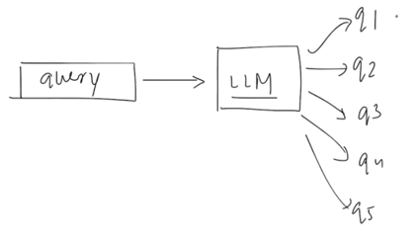
  - What are the best foods to maintain good health?
  - How often should I exercise to stay fit?
  - What lifestyle habits improve mental and physical wellness?
- Each sub-query fetches relevant documents, which are then merged for final results.
Implementation in Code (LangChain Example):
- Import necessary modules, including MultiQueryRetriever.
- Create a vector store with documents.
- Provide an embedding model for converting documents into embeddings.
- Create two retrievers:
  - A normal similarity search retriever.
  - A Multi-Query Retriever using the LLM to generate sub-queries.
- Send the same ambiguous query to both retrievers and compare results.
Observation:
- Normal retriever fetches some relevant documents but may also include unrelated ones due to ambiguity.
- Multi-Query Retriever focuses on the intended context (e.g., health and nutrition) and returns more accurate results aligned with the user’s intent.
Key Benefit:
- Resolves ambiguity in user queries by generating multiple focused sub-queries.
- Ensures that results are relevant and contextually accurate, even for broad or unclear queries.
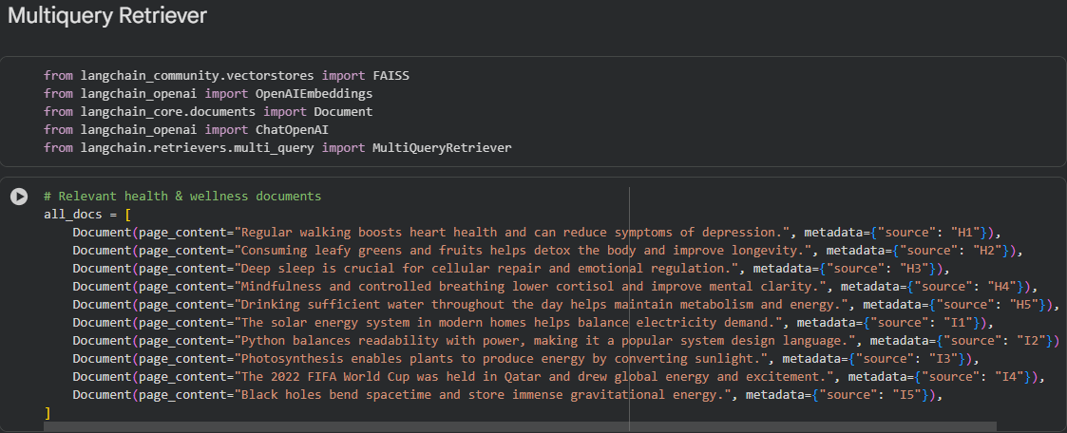
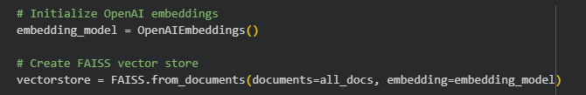
We will create the similarity_retriever as well as multiquery_retriever to compare the results of both
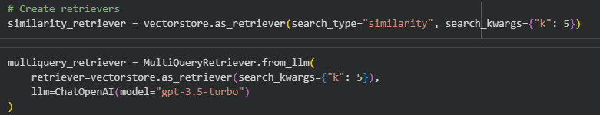
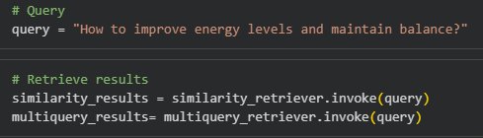
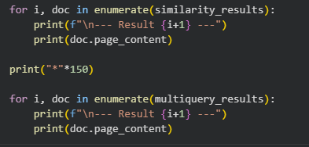
Result of similarity query retriever results – Here we can see that the Result 5 is incorrect which says something about solar energy
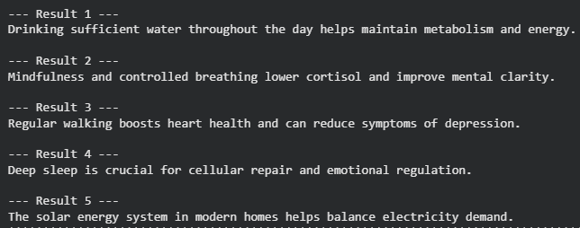
Result of multi query retriever results
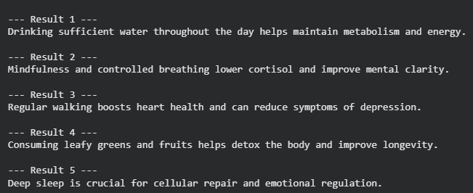

Contextual Compression Retriever
Definition
The Contextual Compression Retriever in LangChain is an advanced retriever that improves retrieval quality by compressing documents after retrieval, keeping only the content relevant to the user’s query.
Problem it Solves
When documents contain multiple topics, a standard retriever may return the full document, which includes irrelevant information for the user’s query. This can degrade user experience, as the answer may be mixed with unrelated content.
How it Works
- The retriever operates in two main parts:
  - Base Retriever: Retrieves documents relevant to the query using a standard retrieval method, such as a similarity search.
  - Compressor: Usually an LLM, this component compresses the retrieved documents, retaining only the parts relevant to the query and discarding irrelevant content.
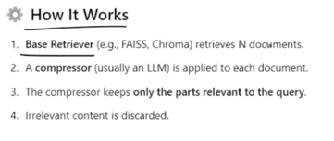
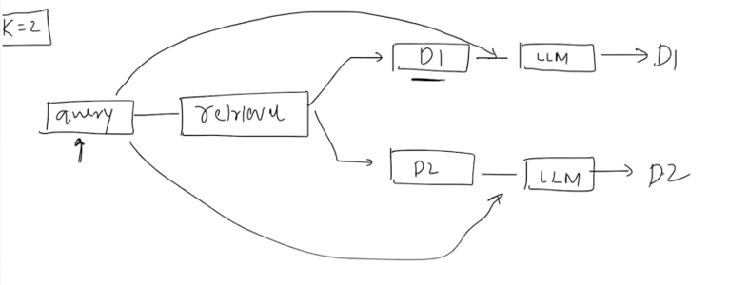
- Example:
A document contains information about both the Grand Canyon and photosynthesis. For the query "What is photosynthesis?", the Contextual Compression Retriever will extract only the sentences about photosynthesis, ignoring content about the Grand Canyon, medieval Europe, or basketball.
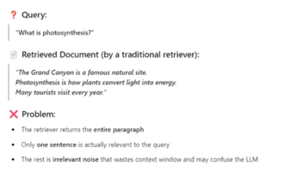
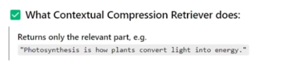
When to Use
- Documents are long and contain mixed information.
- You want to reduce the context length sent to an LLM.
- You aim to improve the answer accuracy in a RAG (Retrieval-Augmented Generation) pipeline.
Implementation Steps
- Create a vector store with your documents and embeddings.
- Initialize a base retriever (e.g., similarity search).
- Initialize a compressor using an LLM.
- Create the Contextual Compression Retriever with the base retriever and the compressor.
- Invoke the retriever with a query to get compressed, relevant results.
Result
- Returns concise answers containing only relevant content.
- Removes irrelevant information automatically, enhancing the user experience and reducing LLM context load.
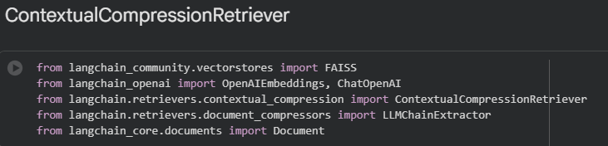
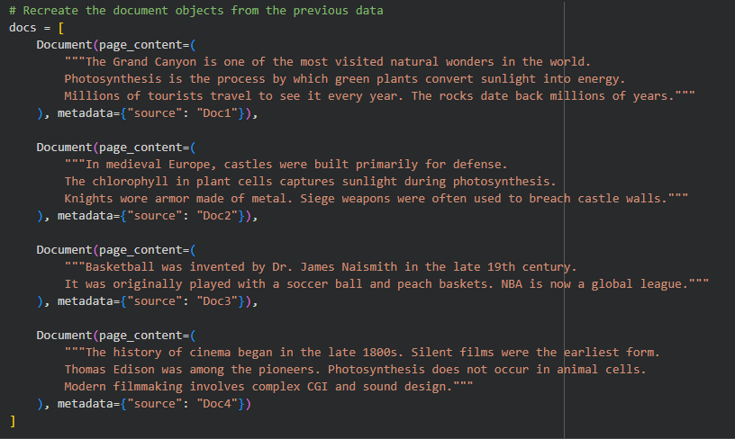
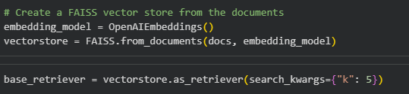
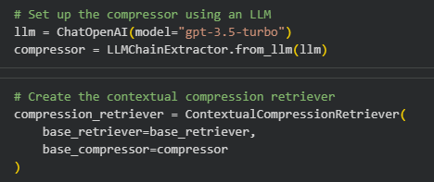
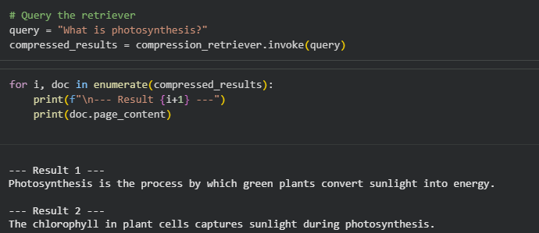

Additional Notes on Other Retrievers
Maximum Marginal Relevance (MMR) Retriever
- Aims to fetch results that are both relevant and diverse.
- Avoids redundancy by selecting documents dissimilar to previously selected ones while maintaining query relevance.
- Controlled by a parameter lambda (0 = more diverse, 1 = behaves like normal similarity search).
Multi-Query Retriever
- Solves issues with ambiguous queries.
- Uses an LLM to generate multiple sub-queries from the original ambiguous query.
- Each sub-query retrieves documents independently, and results are merged to remove duplicates.
- Ensures retrieved results cover different aspects of the ambiguous query while maintaining relevance.
Other Retrievers in LangChain
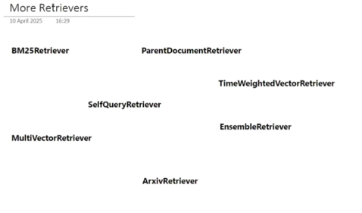
- Parent Document Retriever
- Time-Weighted Vector Retriever
- Self-Query Retriever
- Onsemble Retriever
- Multi Retriever
- These retrievers exist to solve specific problems, such as filtering by time, hierarchies in documents, or combining multiple retrieval strategies.
- Choosing a retriever depends on the use case and the type of documents or queries in your system.
General Advice
- Different retrievers are often used to improve RAG-based systems.
- For complex projects, experimenting with different retrievers can help improve system performance and answer quality.

